**ASSIGNMENT 1 REPORT**



**BIG DATA ENGINEERING**

**Assignment 1: Data Lakehouse with Snowflake**

**BALAKUMARAN SIVANESAN 24883302.**

**Table of Contents**

**Overview of the project: 2**

**Part 1: Data ingestion 3**

**Part 2: Data Cleaning: 6**

**Part 3: Data Analysis: 9**

**Part 4: Business Question 12**

**Challenges and Solutions: 13**

**Conclusion: 13**

# Overview of the project:

The main objective of the project is to analyse the YouTube data to gain insight into a content strategy for launching a successful YouTube Channel. This project involves building a Data Lakehouse using Snowflake for analysing the Data, The Data includes CSV for YouTube trending and JSON for YouTube categories. The objective was to upload the data into a cloud storage system (Azure Blob Storage), ingest it into Snowflake, perform transformations, clean the data, and conduct analysis to answer specific business and data questions.

The overall process followed the **ETL (Extract, Transform, Load) pipeline model**:

1. **Data Ingestion**: Loading the data from Azure Blob Storage into Snowflake external tables.
2. **Data Transformation**: Cleaning and joining the trending videos and category data.
3. **Data Analysis**: Conducting SQL queries to extract insights and answer specific questions.

The analysis will comprise into **four main parts:**

* **Part 1:** Data ingestion: Steps to ingest data from Azure Blob Storage into Snowflake.
* **Part 2:** Data Cleaning: Steps to clean the Data and ensures the Data is ready for Analysis.
* **Part 3:** Data Analysis: Steps to Analyse the Data and provides valuable insights and information from the data.
* **Part 4:** Business Question: With the results from the previous parts, we’ll utilize it to answer the given Business question.

Overall, the project results will highlight insights into YouTube trends and give some recommendations, which can be a foundation for informed content creation and promotion strategies in launching a new YouTube Channel.

# Part 1: Data ingestion

The first task was to ingest the dataset into Snowflake. The dataset comprised daily YouTube trending data in CSV format for ten different countries and category information in JSON format. The data was uploaded to an Azure Blob Storage account,

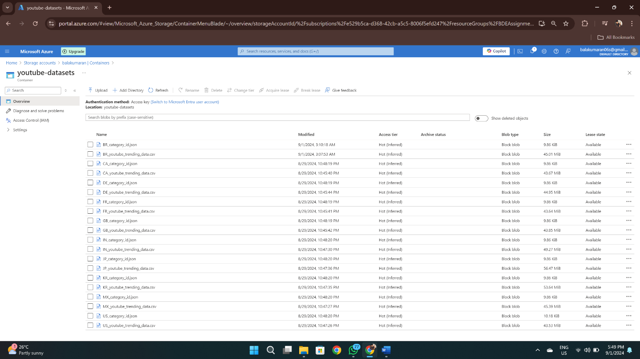

and in Snowflake I created both Database and Stage as CREATE DATABASE & CREATE STAGE command to create an external stage that pointed to the Azure storage.

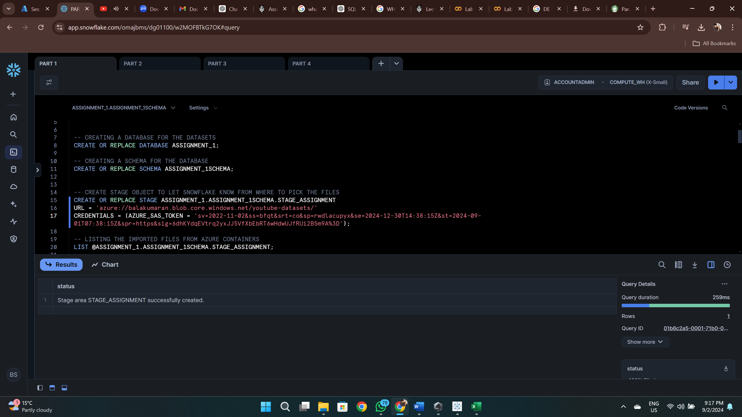

Two external tables were created:

* **EX_TABLE_YOUTUBE_TRENDING** for trending data.

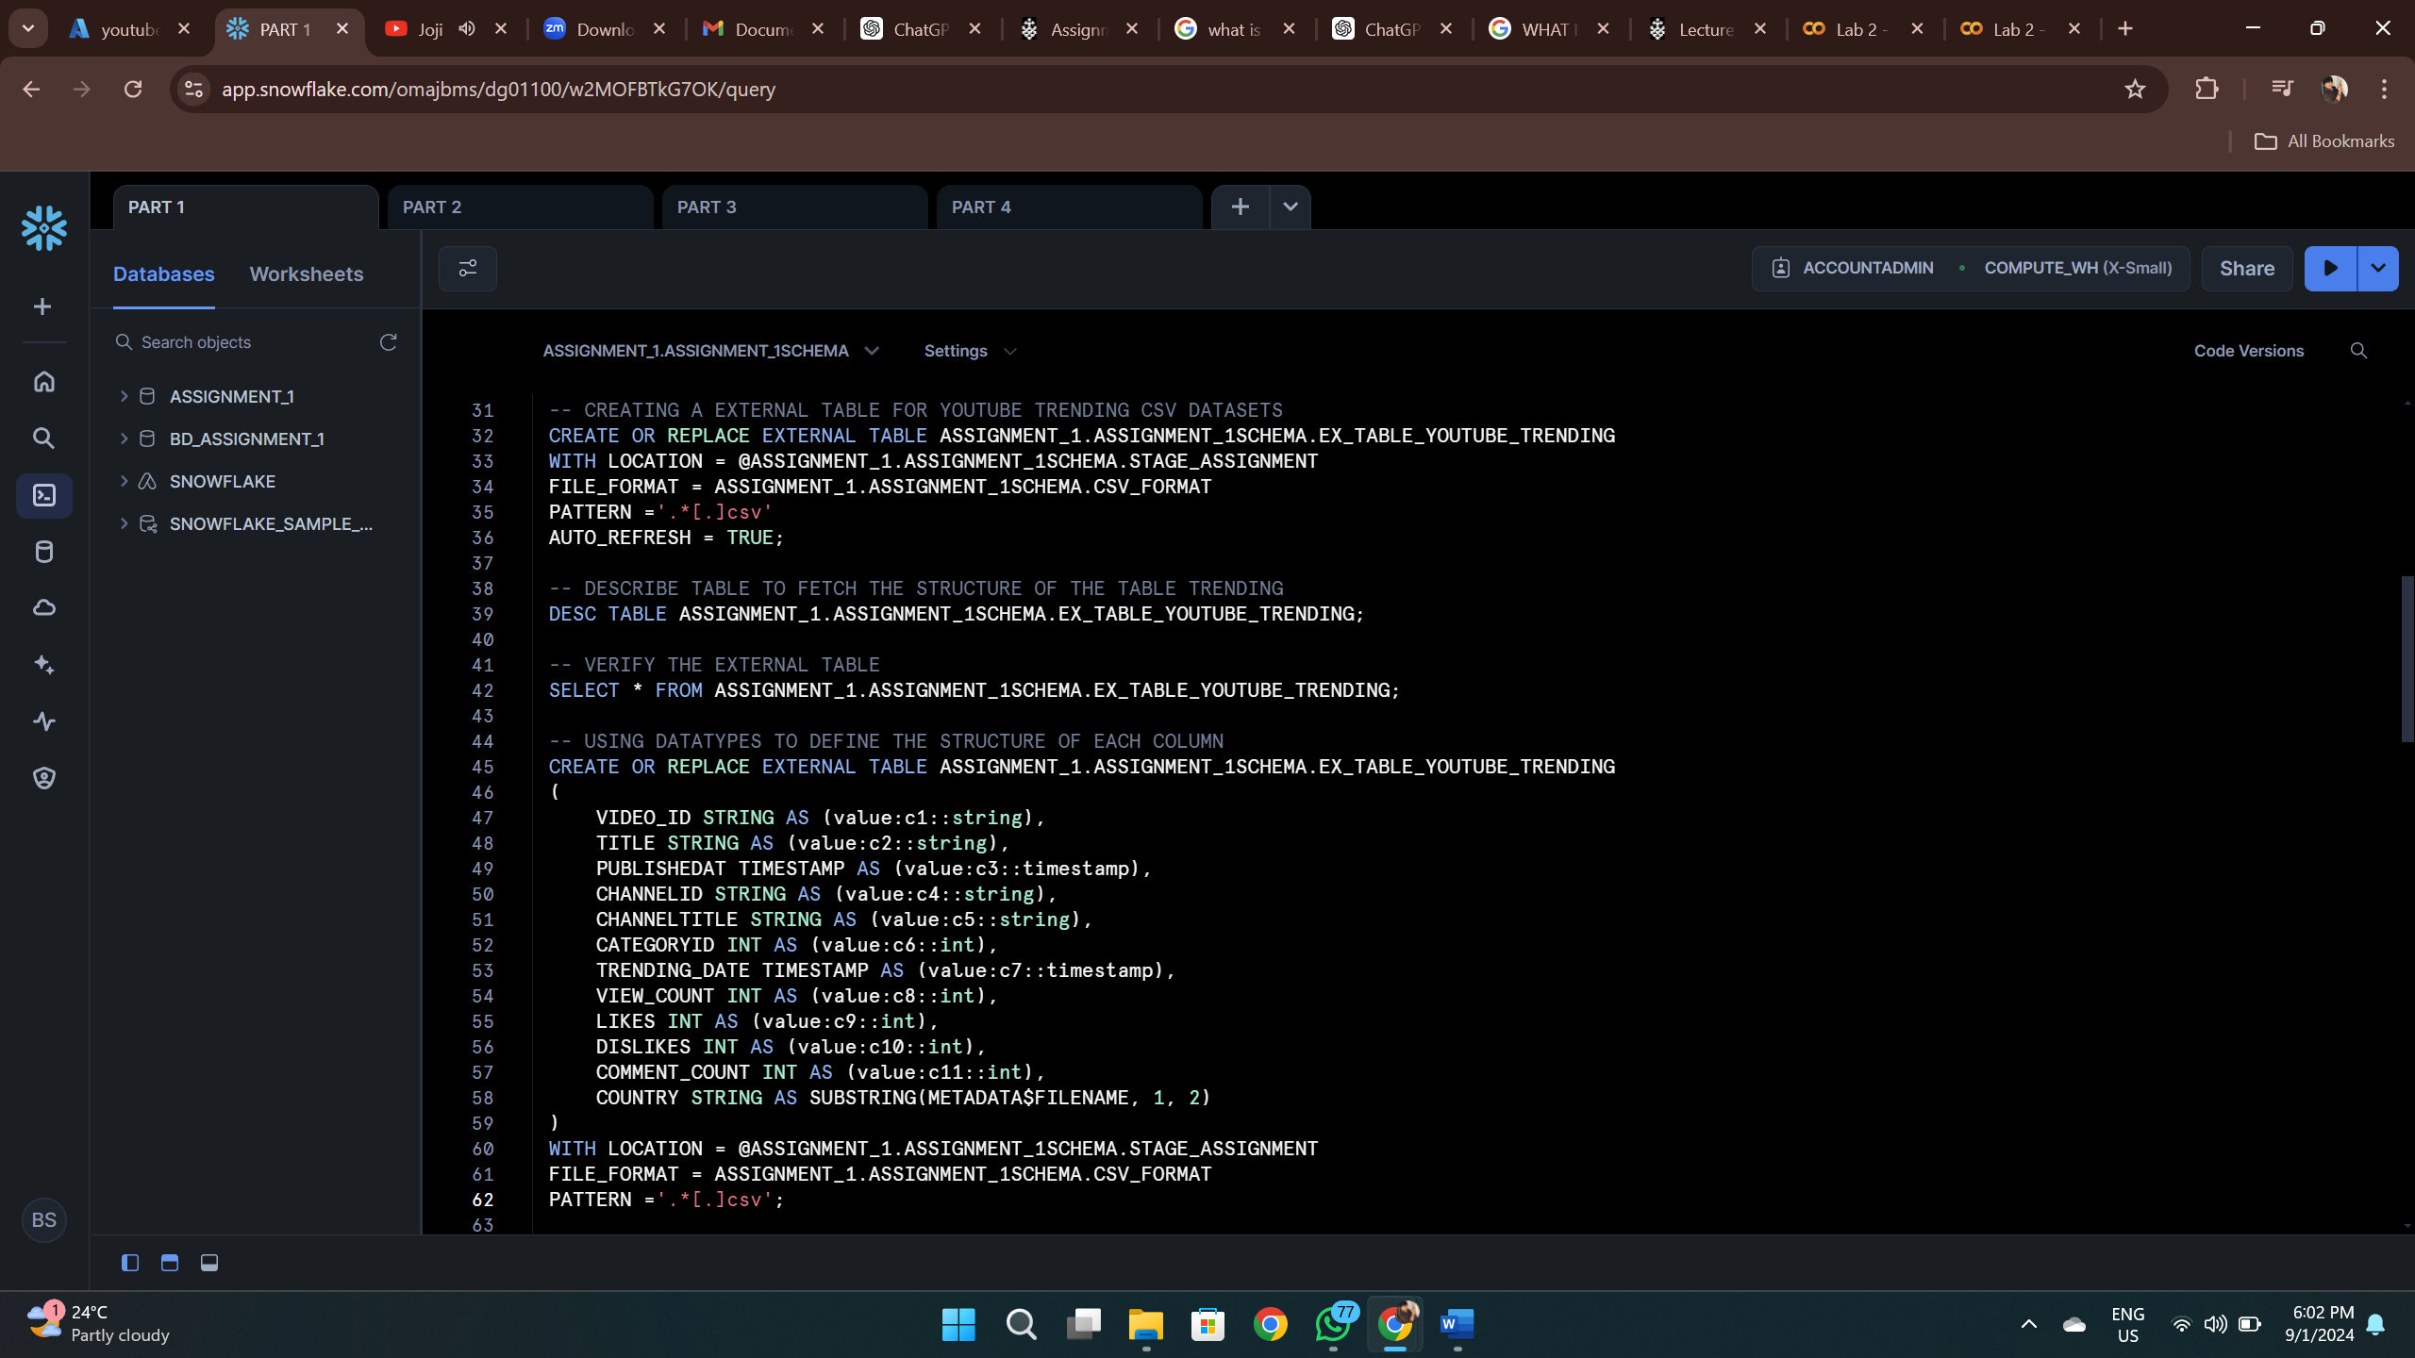

* **EX_TABLE_YOUTUBE_CATEGORY** for category data.

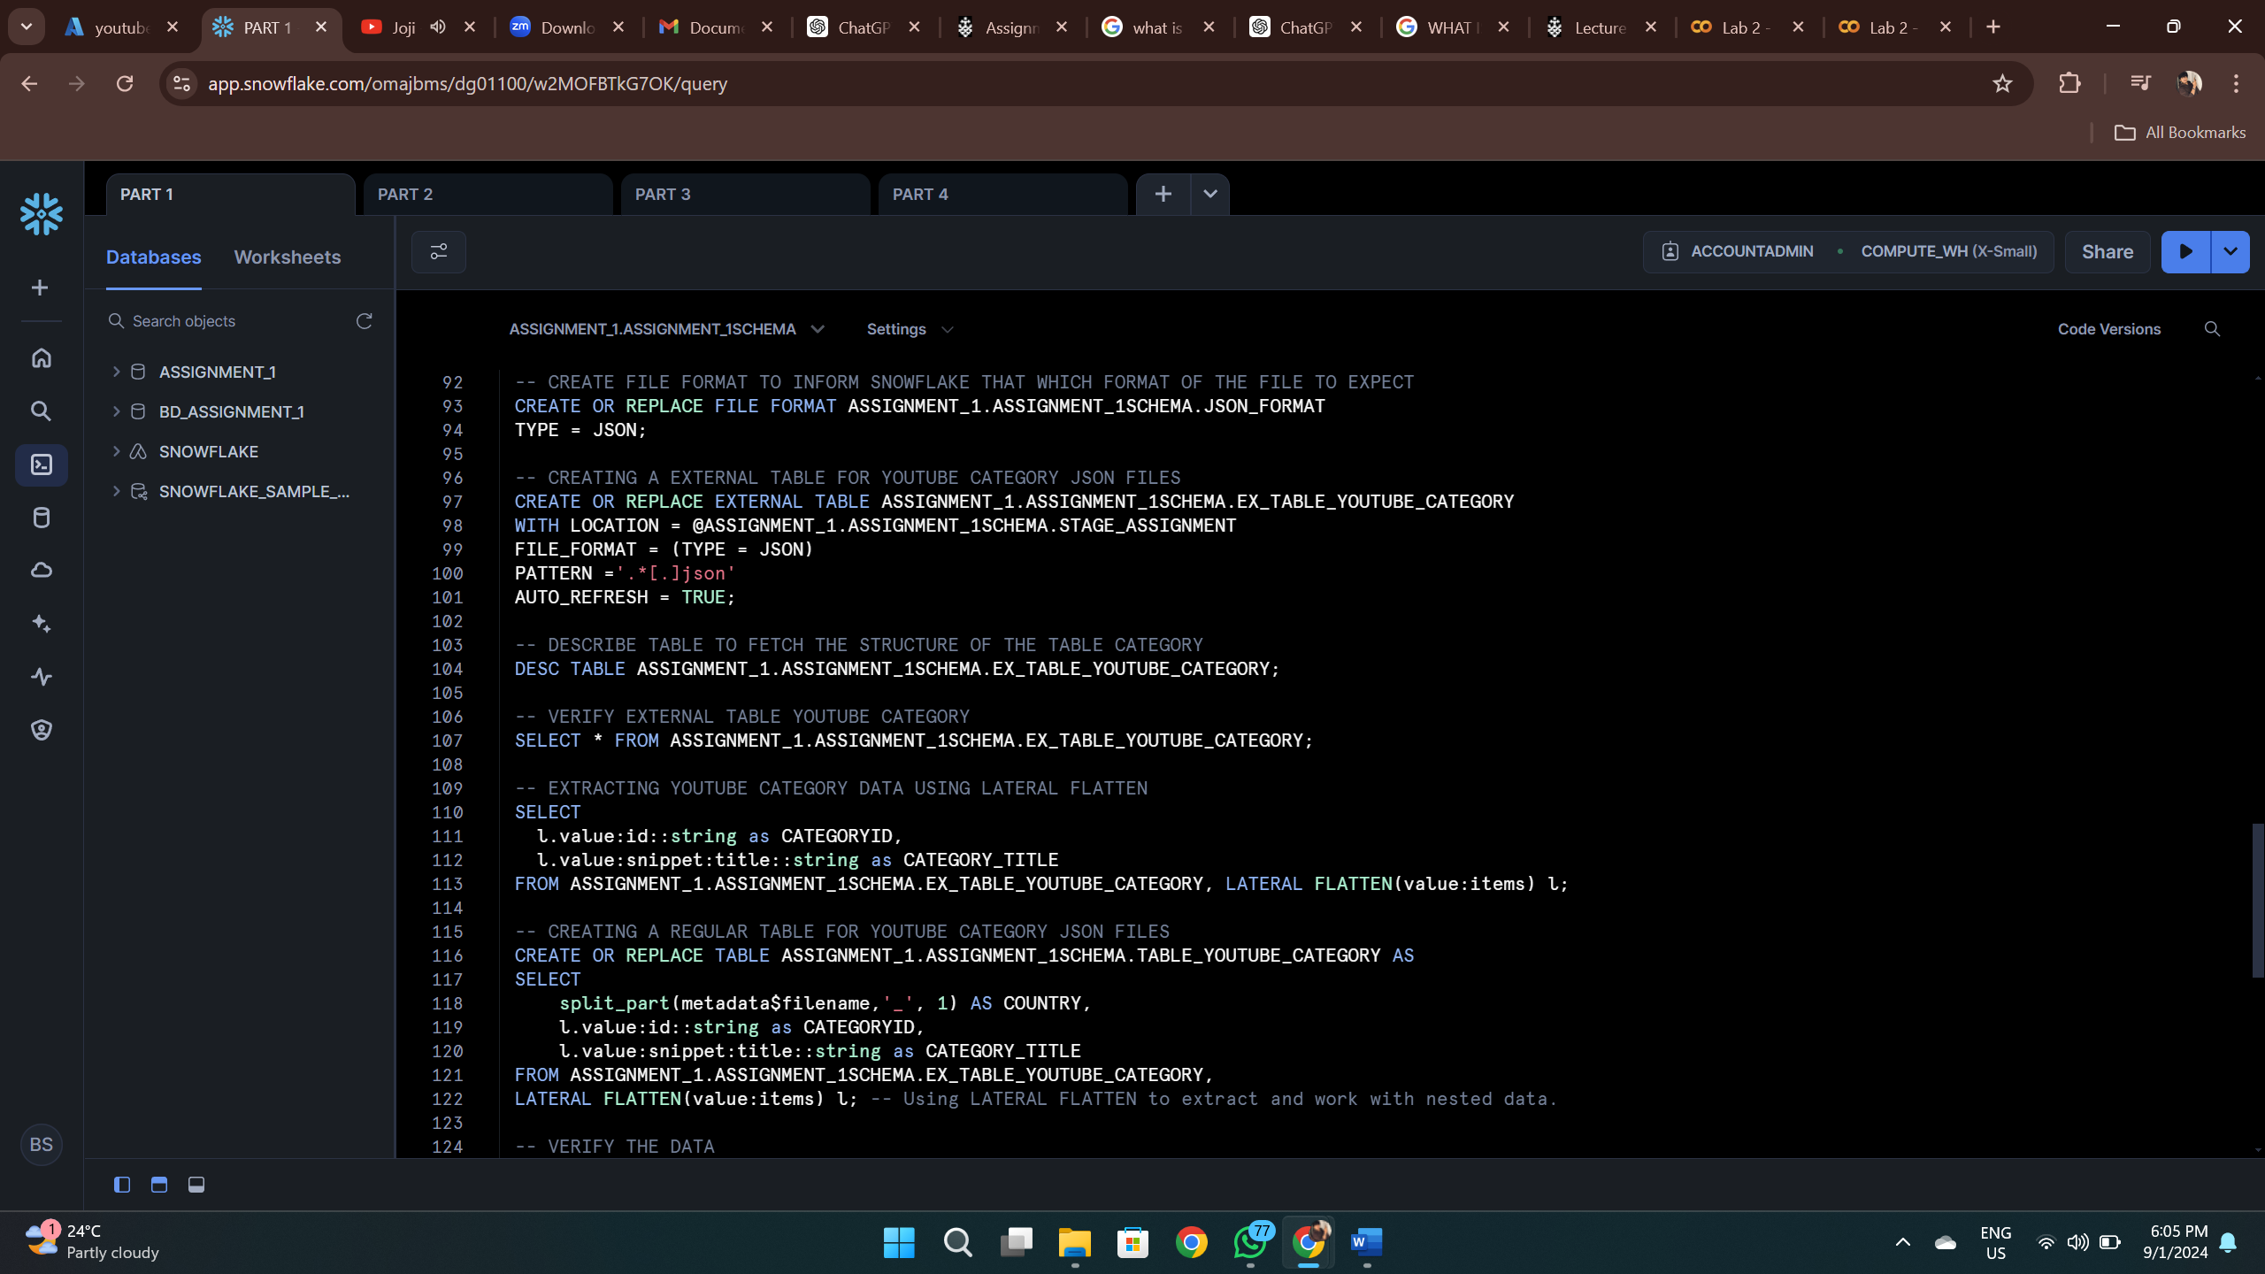

Data was then transformed into regular tables from external tables as

**TABLE_YOUTUBE_TRENDING**

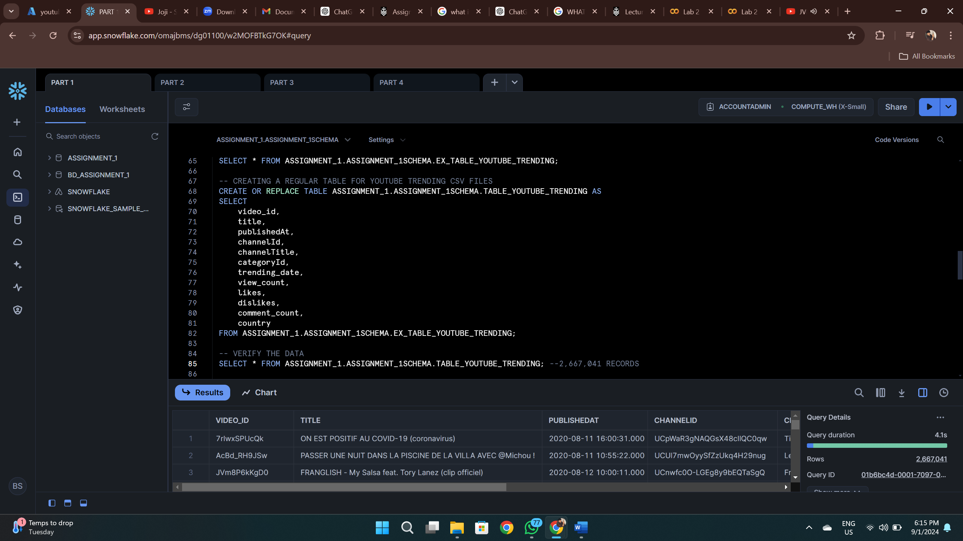

**TABLE_YOUTUBE_CATEGORY**

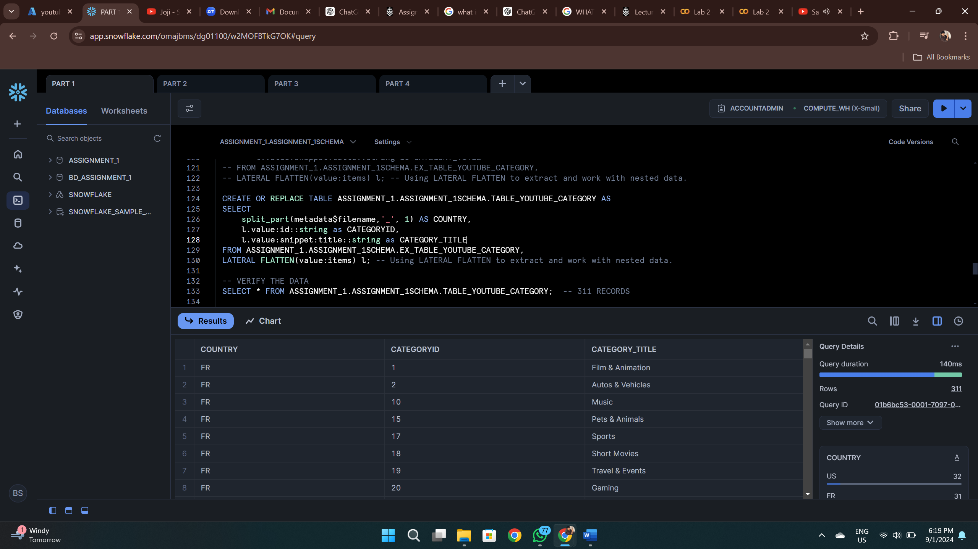

And then I created a final table called **TABLE_YOUTUBE_FINAL** by combining **TABLE_YOUTUBE_TRENDING** and **TABLE_YOUTUBE_CATEGORY**

On Country and **Category**, while adding a new field called **id** by using the **UUID_STRING()** function :

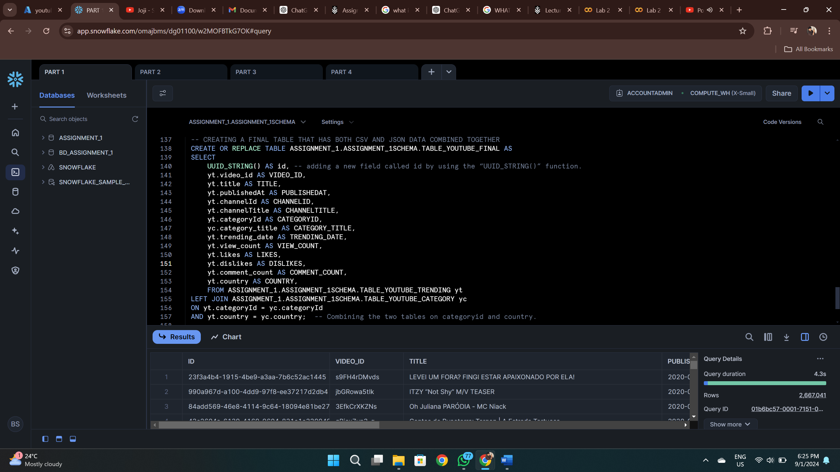

Finally, the **TABLE_YOUTUBE_FINAL** has **2667041 RECORDS.**

In summary, the process of importing data into Snowflake from Azure Blob Storage was carried out successfully. The process involved creating external tables for the YouTube trending and category datasets, which allowed the data to be imported into Snowflake in an efficient manner. The final combined table with UUIDs produced a dataset with 2,667,041 rows, which is the expected result. The process verified that large datasets were correctly ingested and transformed into Snowflake Data Lakehouse.

# Part 2: Data Cleaning:

Several data cleaning steps were performed to ensure the data was accurate:

1. In “**TABLE_YOUTUBE_FINAL**” which **CATEGORY_TITLE** has duplicates if we don’t take into account the **CATEGORYID** (return only a single row)?

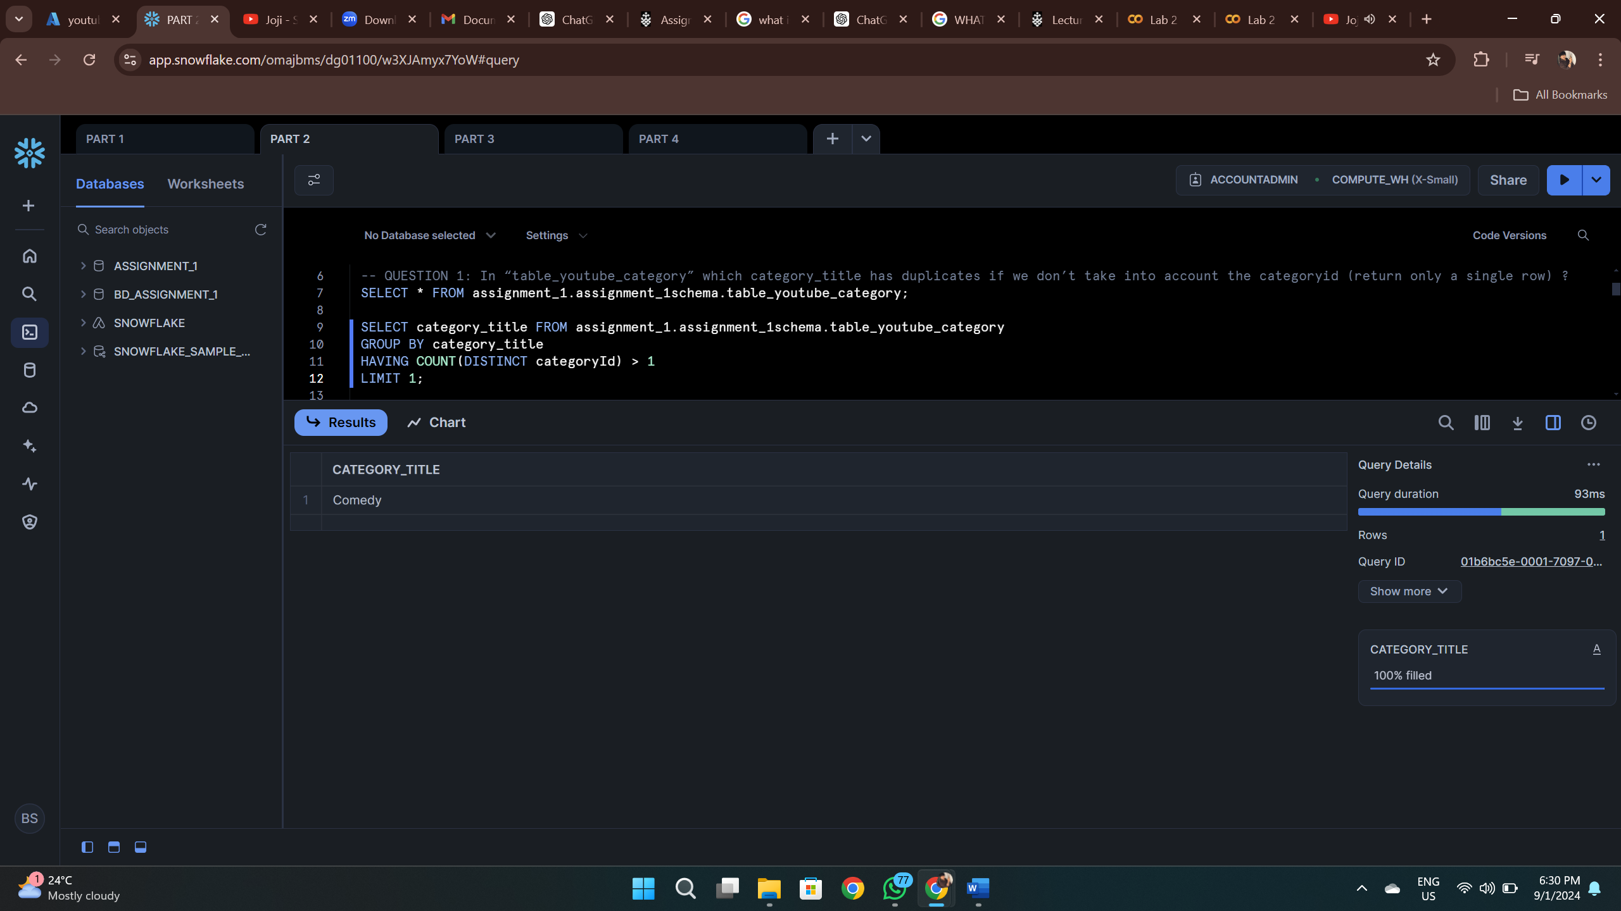

Comedy is the only Category_title which has duplicates

1. In “**TABLE_YOUTUBE_FINAL**”which “**CATEGORY_TITLE**”only appears in one country?

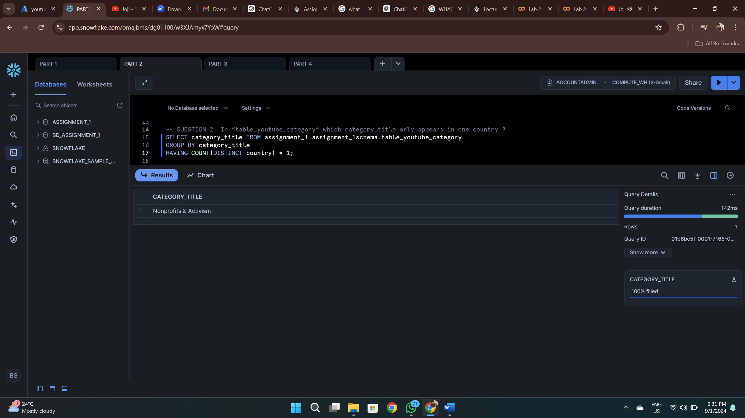

Nonprofits & Activism appeared only in one country, which helped identify region-specific content.

1. In “**TABLE_YOUTUBE_FINAL**”, what is the **CATEGORYID** of the missing “**CATEGORY_TITLES**”?

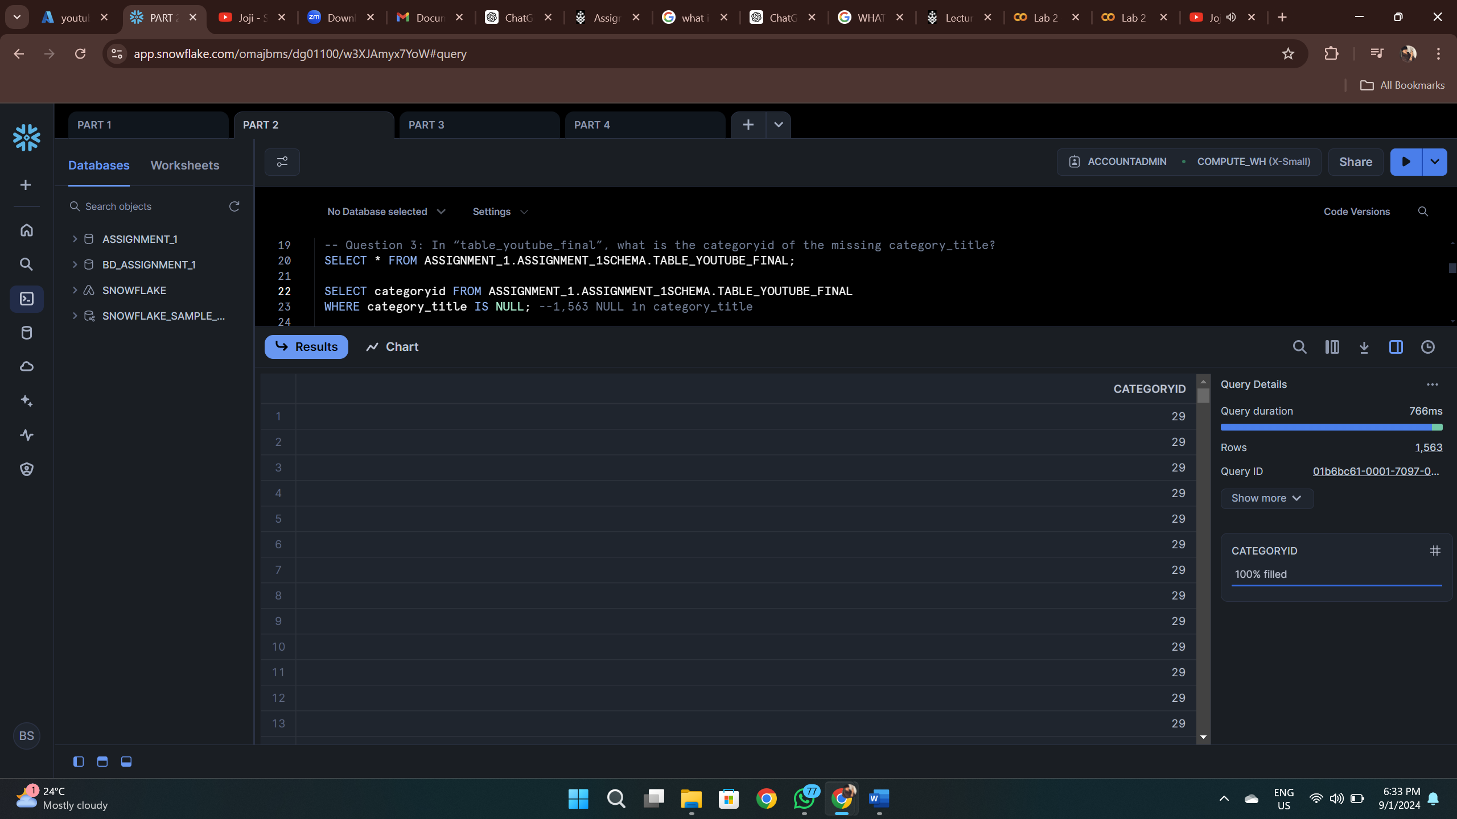

We can clearly see that we have 1,563 Records of NULL category_title.

1. Update the “**TABLE_YOUTUBE_FINAL**”to replace the NULL values in “**CATEGORY_TITLE**” with the answer from the previous question.

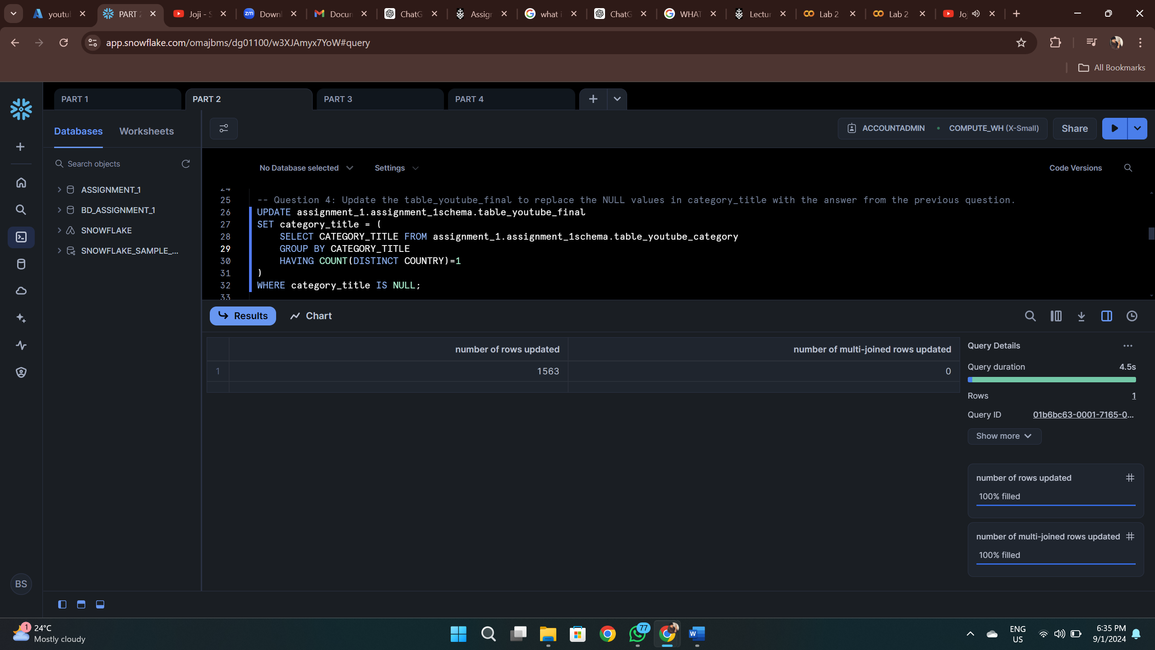

I replaced NULL values in the category_title field of table_youtube_final using values identified through earlier queries.

1. In “table_youtube_final”, which video doesn’t have a channeltitle (return only the title)?

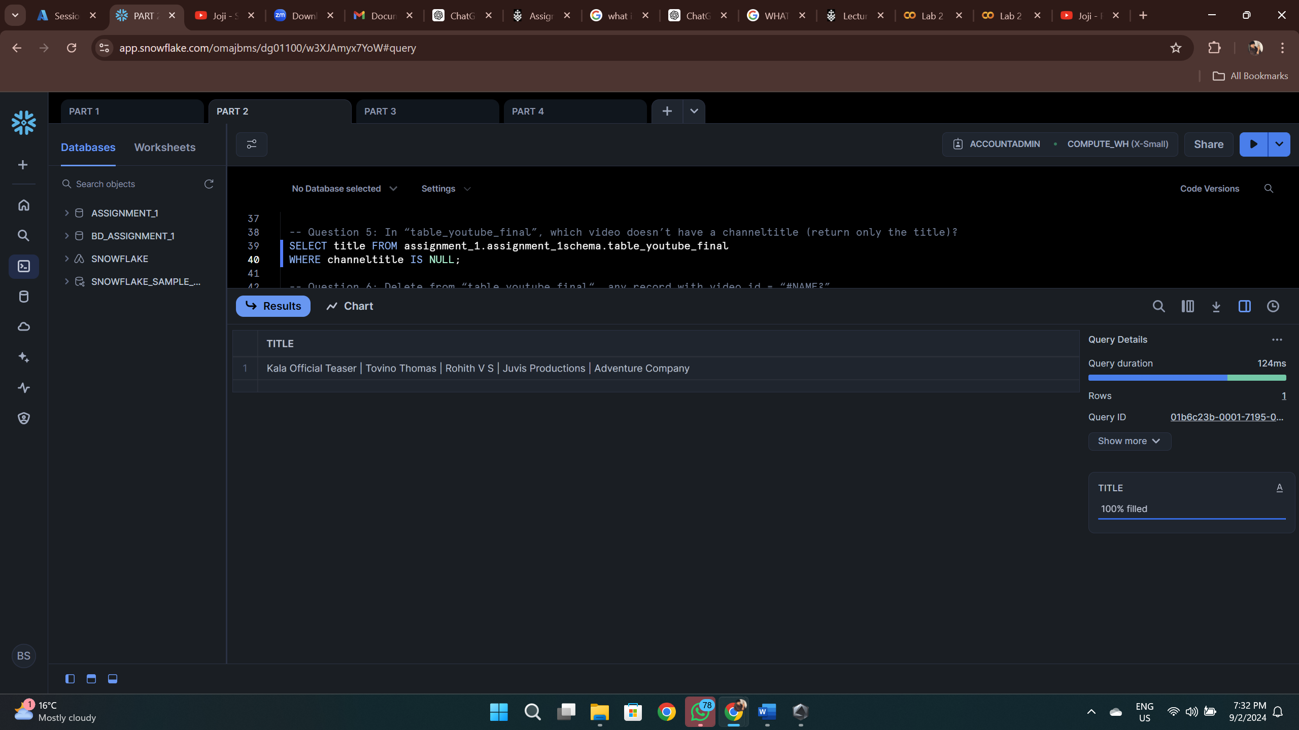

Kala Official Teaser | Tovino Thomas | Rohith V S | Juvis Productions | Adventure Company Video doesn’t have a Channeltitle from TABLE_YOUTUBE_FINAL.

1. Delete from “*table_youtube_final*“, any record with *video_id* = “#NAME?”

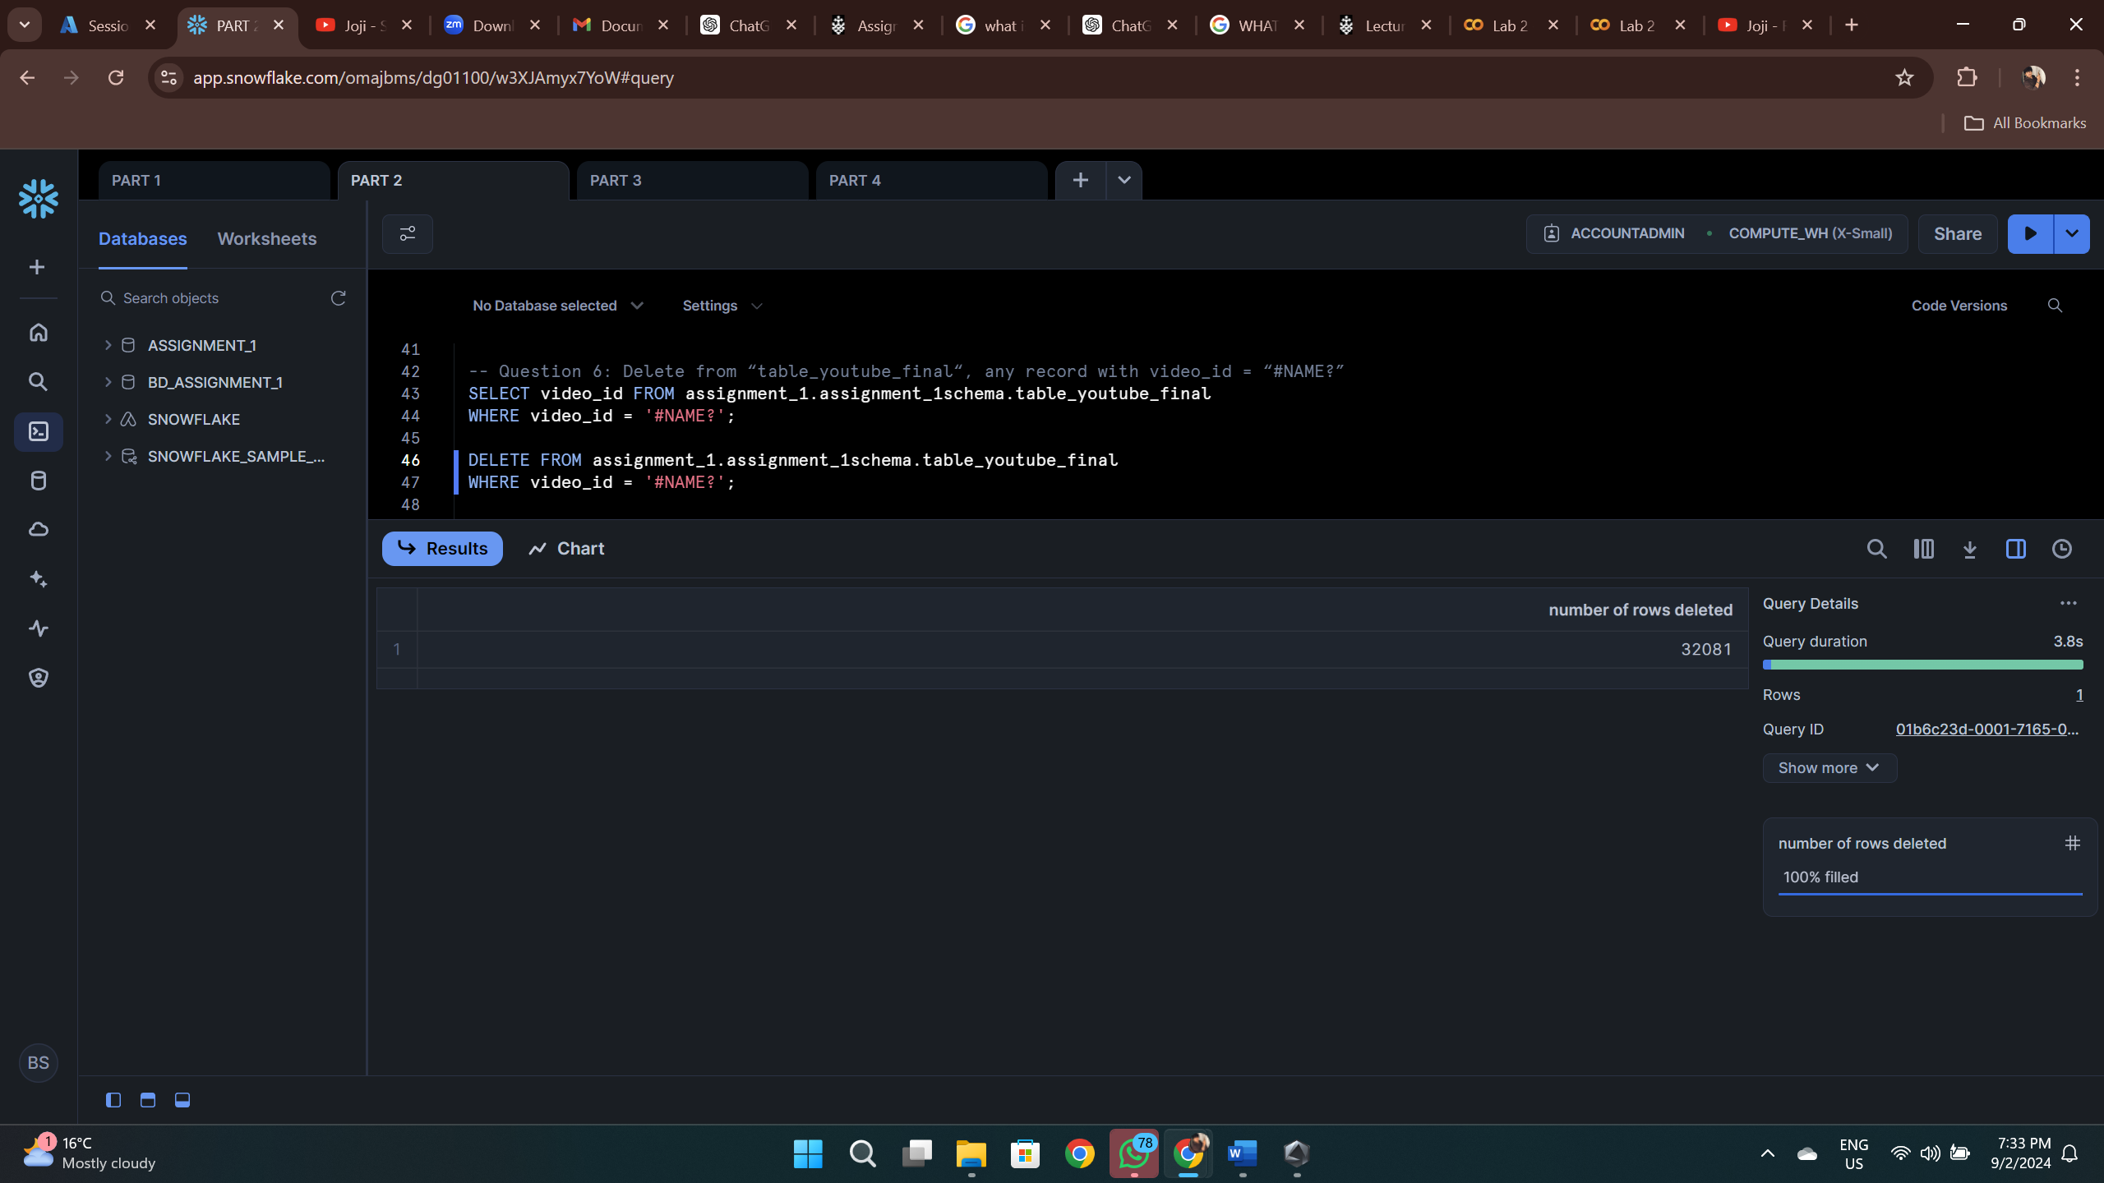

32081 Records were deleted from Table_Youtube_Final with Video_id = “#NAME?”.

1. Duplicate Videos: Some records in the dataset had the same video_id, country, and trending_date, but varying metrics. I used the ROW_NUMBER() function to identify duplicates, selecting the record with the highest view count and deleting the others

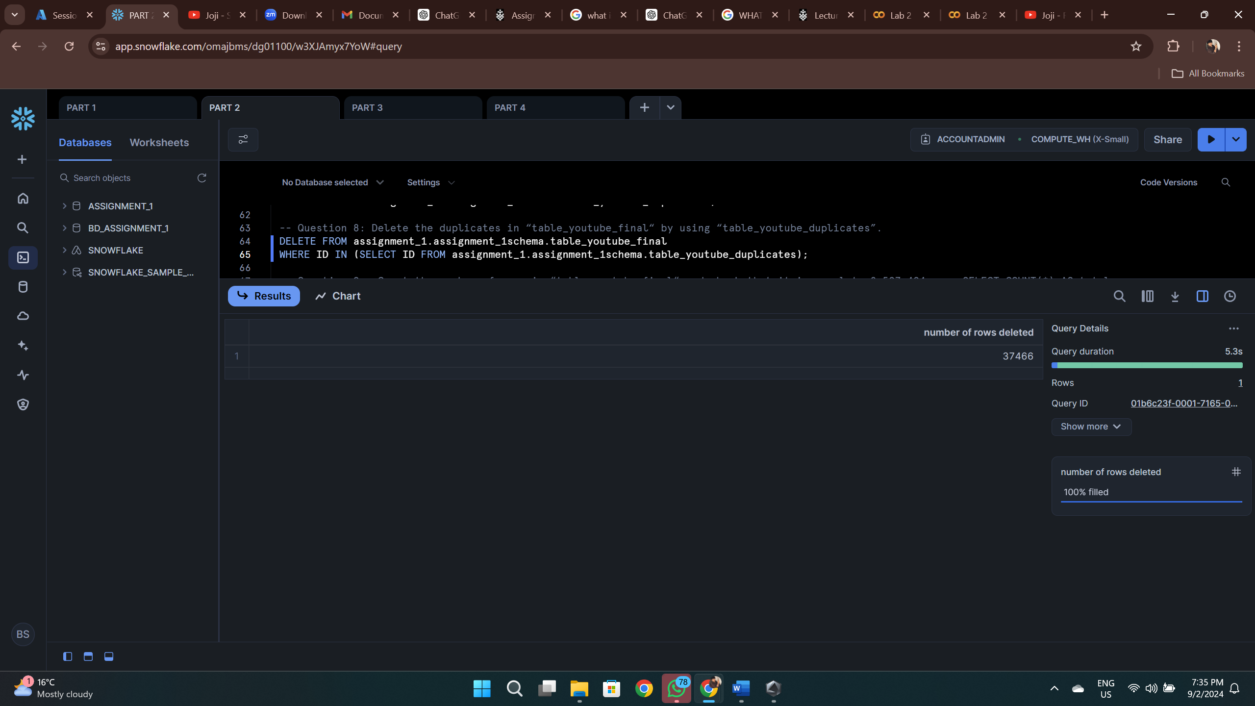

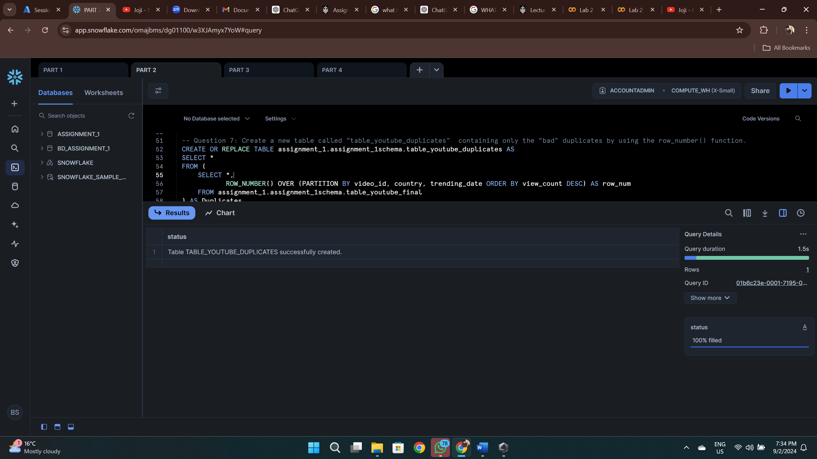

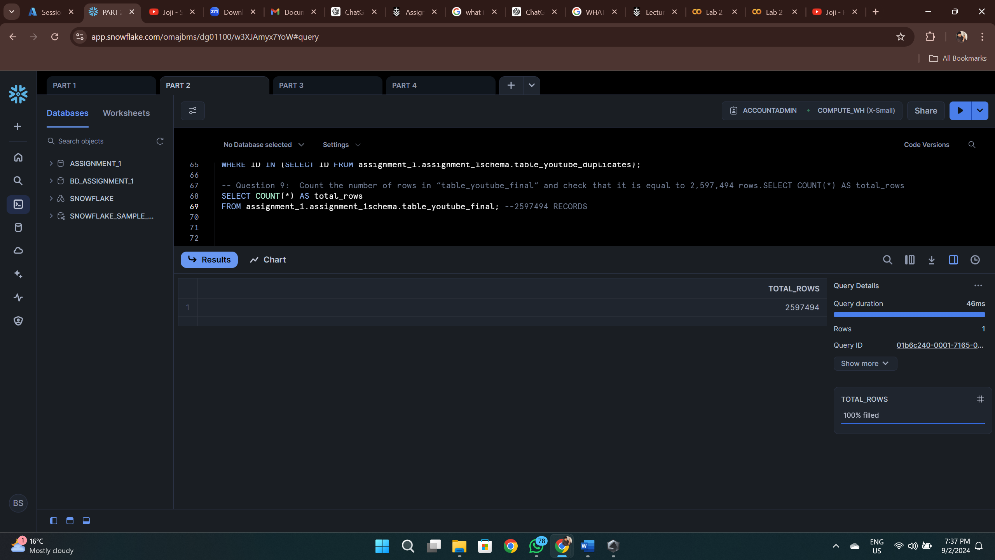

This process reduced the row count to 2,597,494 in the final cleaned table.

In summary this phase, we focused on improving data integrity by identifying and addressing key issues like missing values, duplicates, and inconsistencies in the dataset. By resolving the duplicates in category titles and ensuring missing values for category titles were replaced correctly, we enhanced the overall quality of the data. Additionally, handling duplicate rows based on video metrics allowed us to retain only the most relevant records. The final dataset contained 2,597,494 rows; this phase ensured that the dataset was in optimal shape for accurate analysis in the following stages.

# Part 3: Data Analysis:

This analysis section involved running several SQL queries to answer specific questions regarding YouTube’s trending data:

1. Most Viewed Videos by Country in Gaming: I identified the top 13 most viewed gaming videos for each country on the trending date of 2024-04-01.

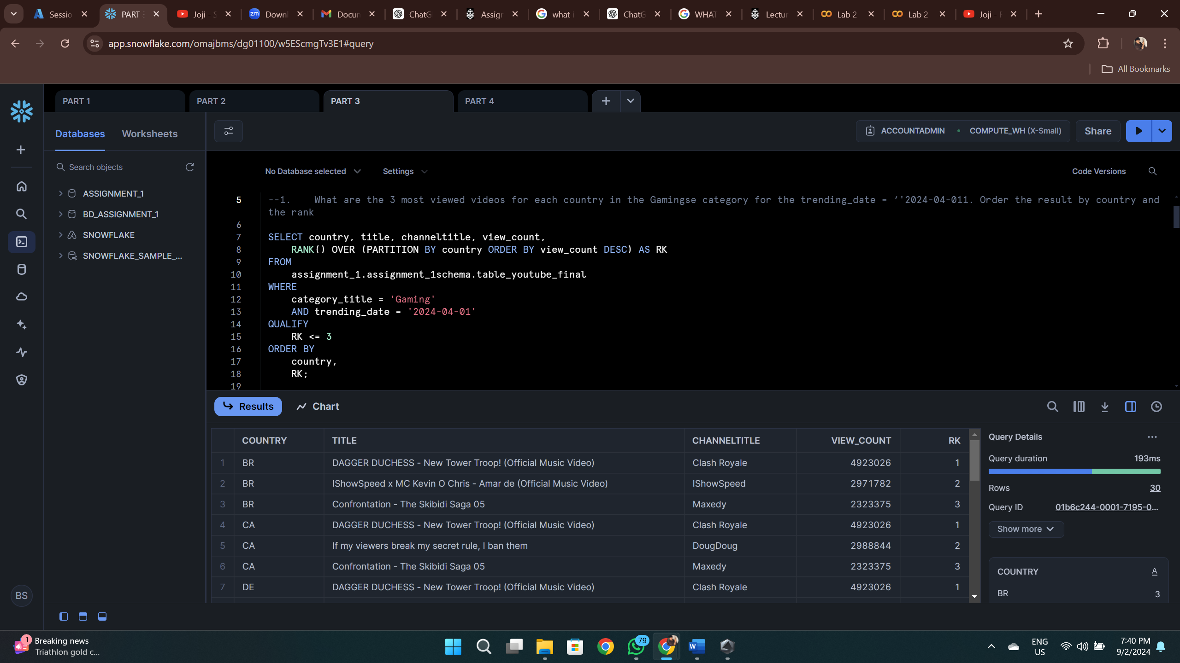

1. Videos Containing 'BTS': I counted distinct video titles containing the word “BTS” (case insensitive) for each country and ranked them in descending order by count.

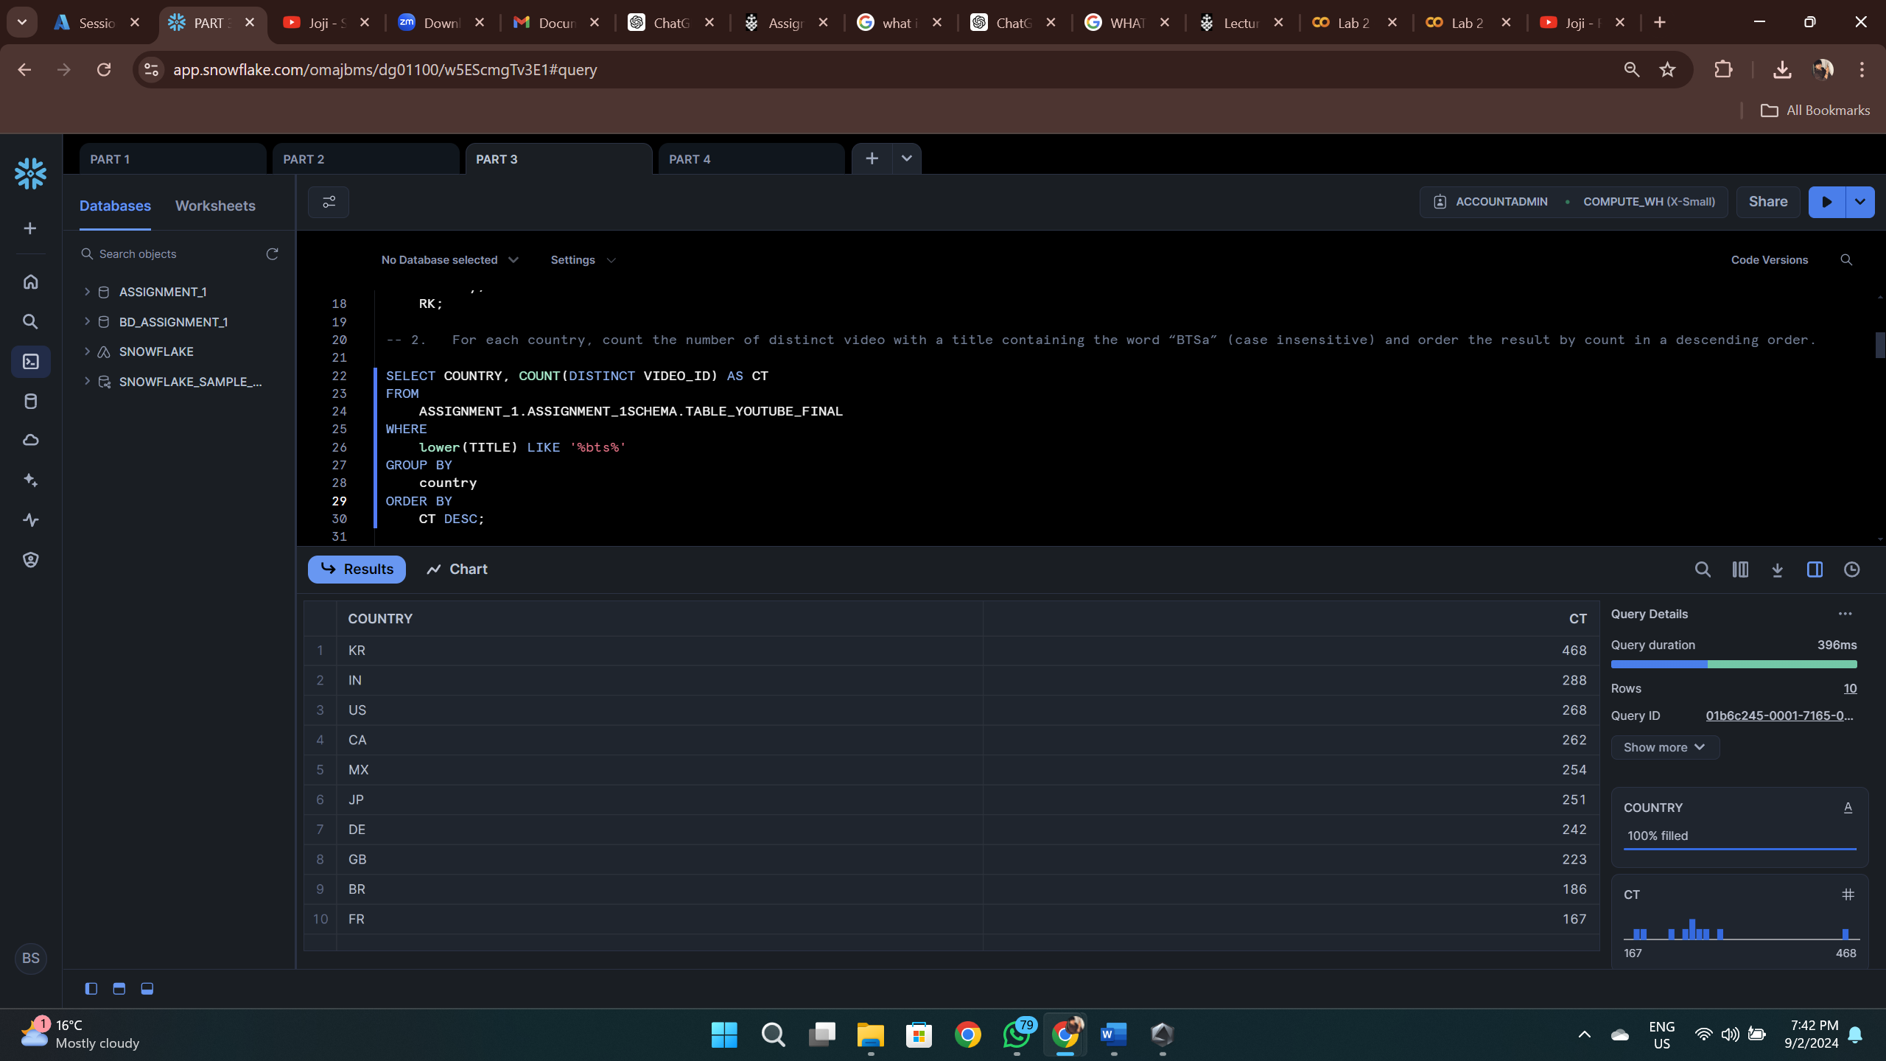

1. Most Viewed Video with Likes Ratio: For each country and month before 2024, I calculated the video with the highest view count and its likes-to-views ratio, formatted to 12 decimals.

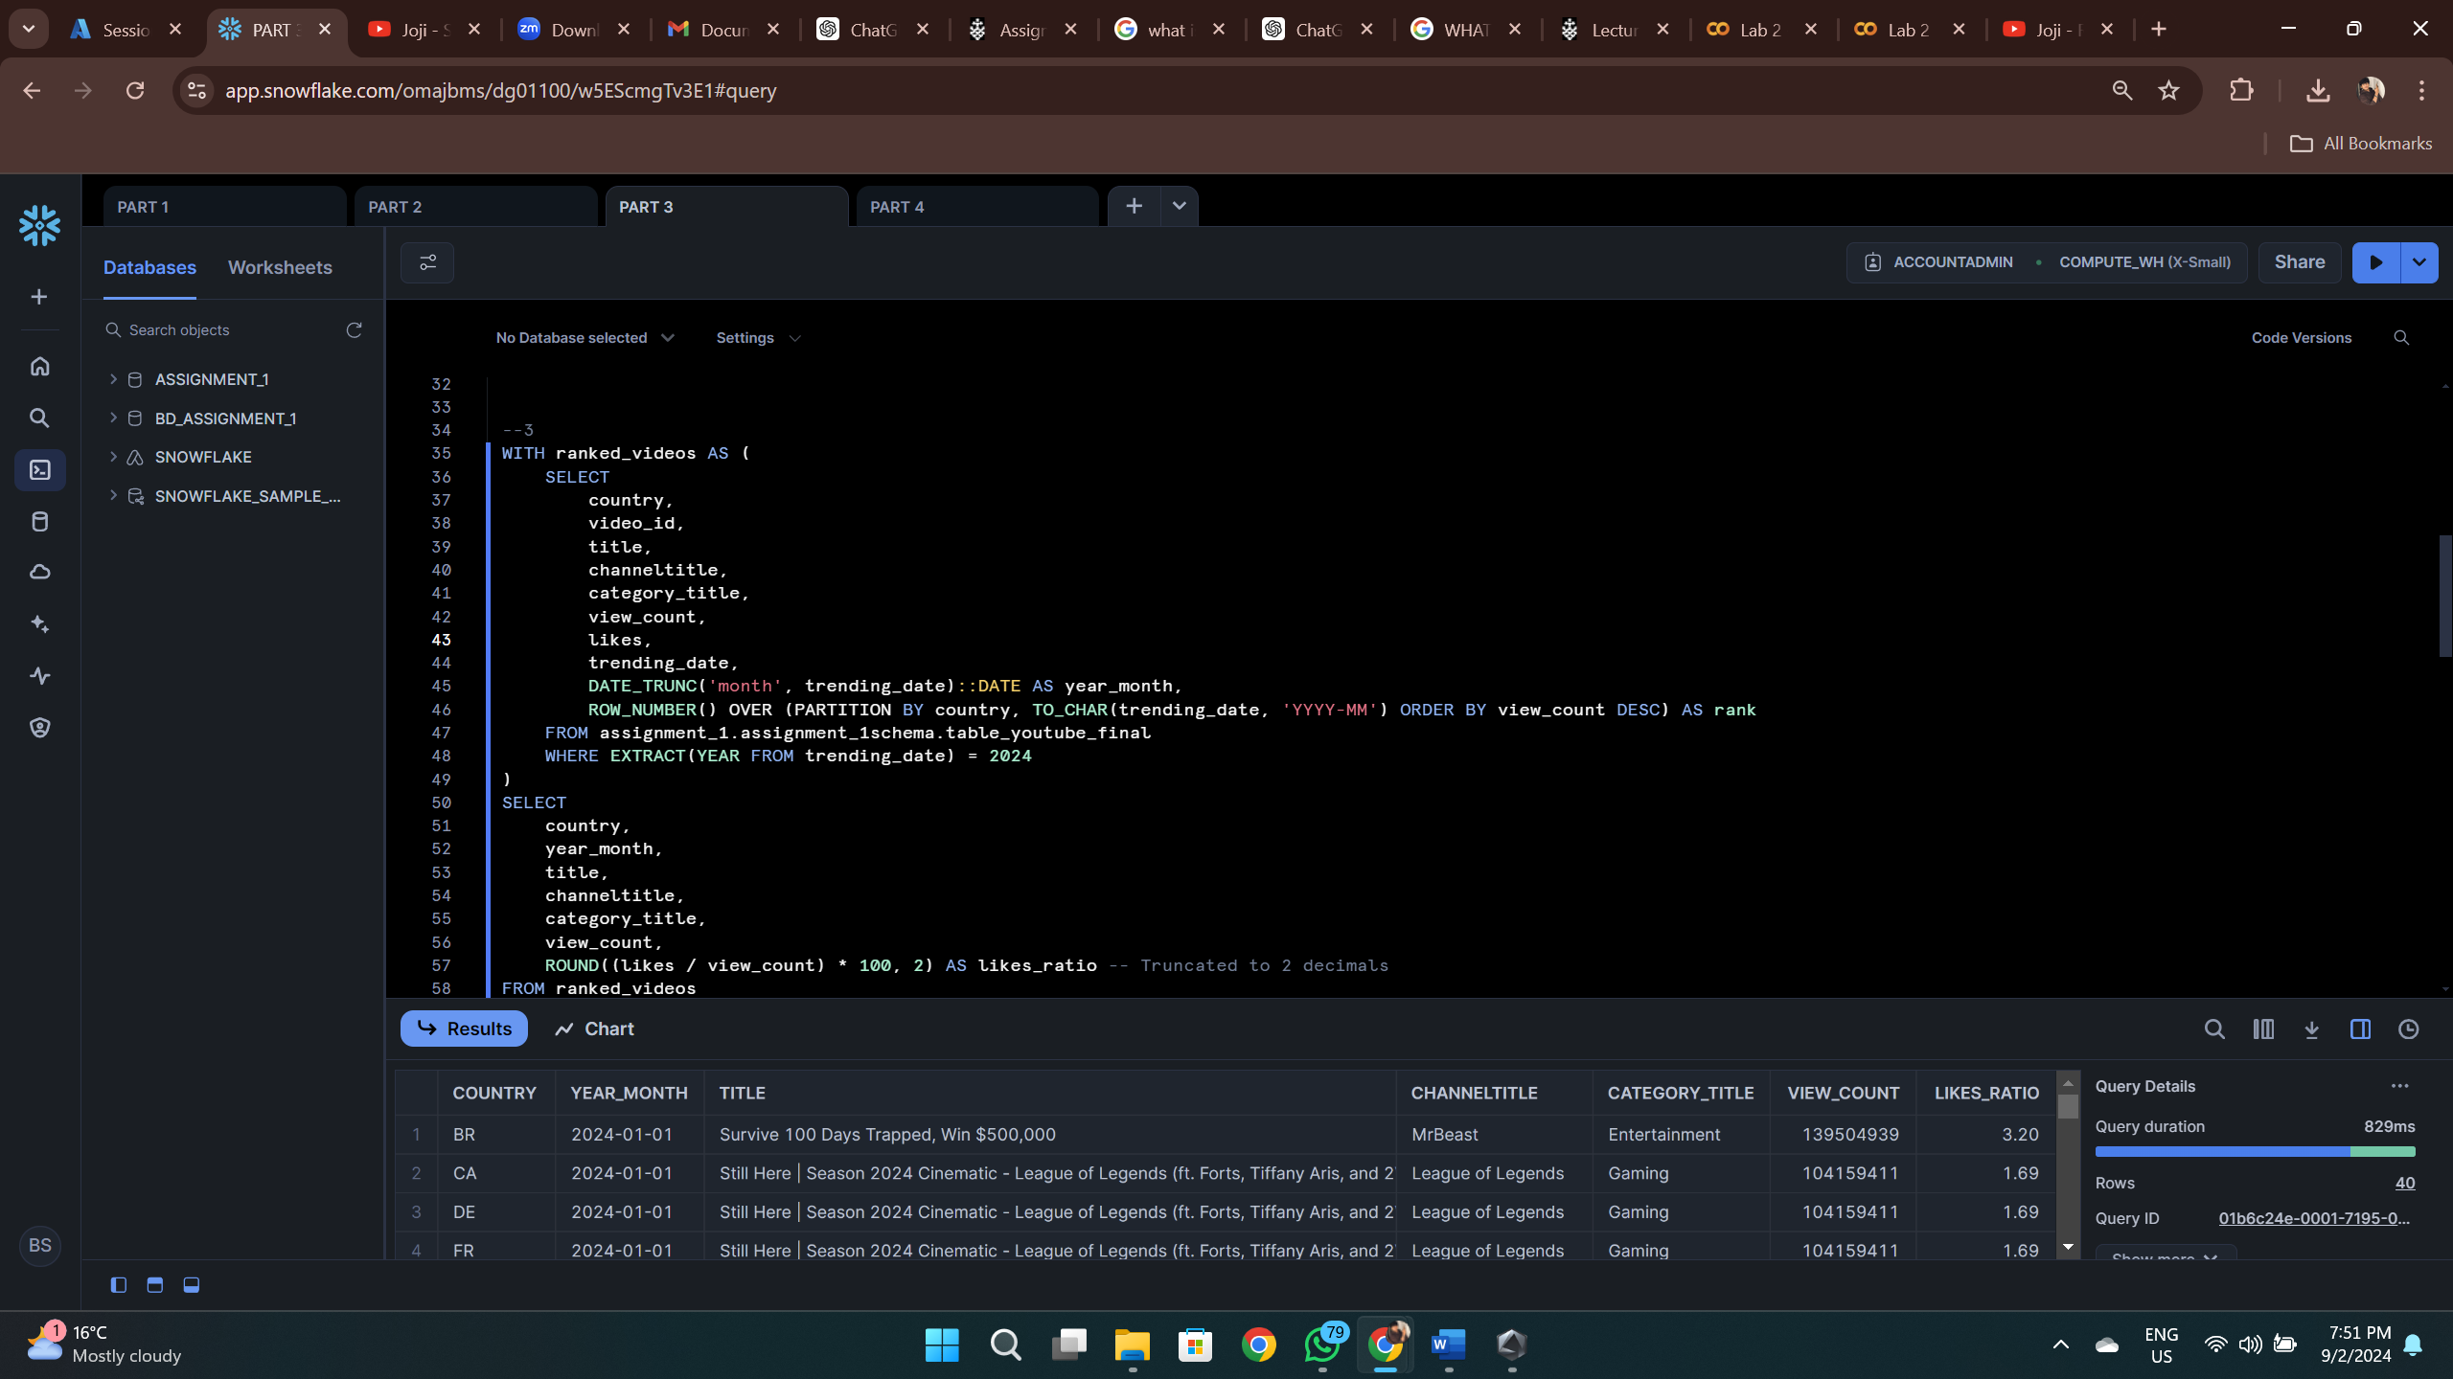

1. Distinct Video Count by Category: For each country, I calculated which category_title had the most distinct videos and its percentage out of the total video count, focusing only on data before 2022.

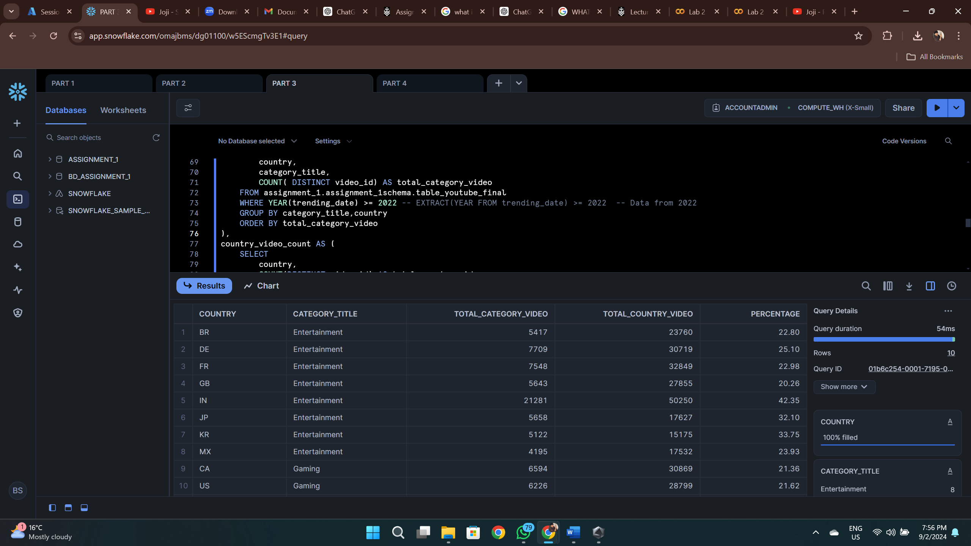

1. Top Channel by Distinct Video Count: I found the channeltitle with the most distinct video uploads, along with the total count.

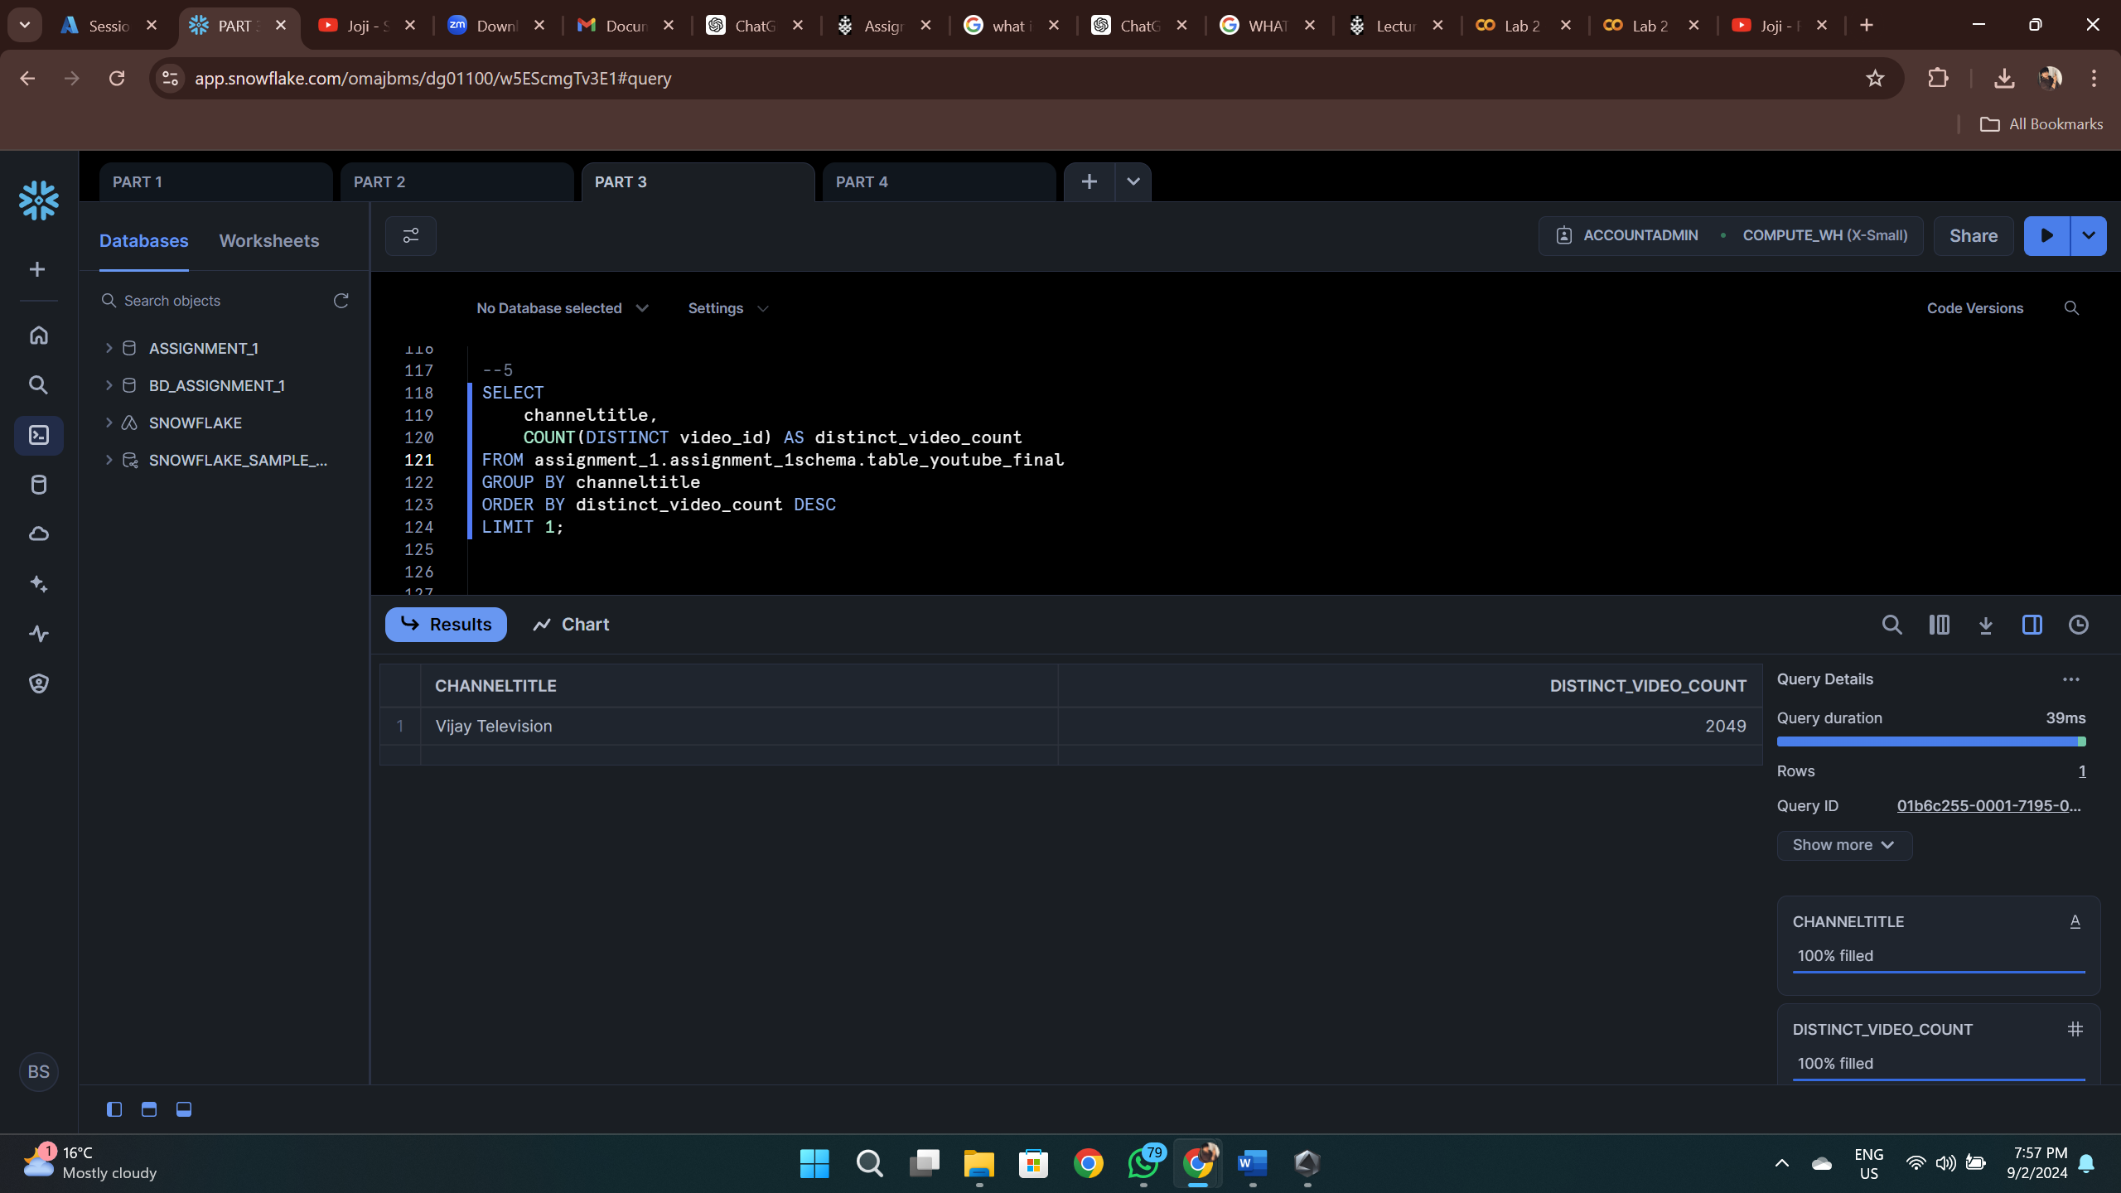

Vijay Television has the most distinct video uploads with highest distinct video count of **2049**

# Part 4: Business Question

The final part of the assignment involved answering a business question regarding launching a new YouTube channel. Based on the analysis of trending data, if I were to launch a new channel tomorrow, excluding Music and Entertainment categories

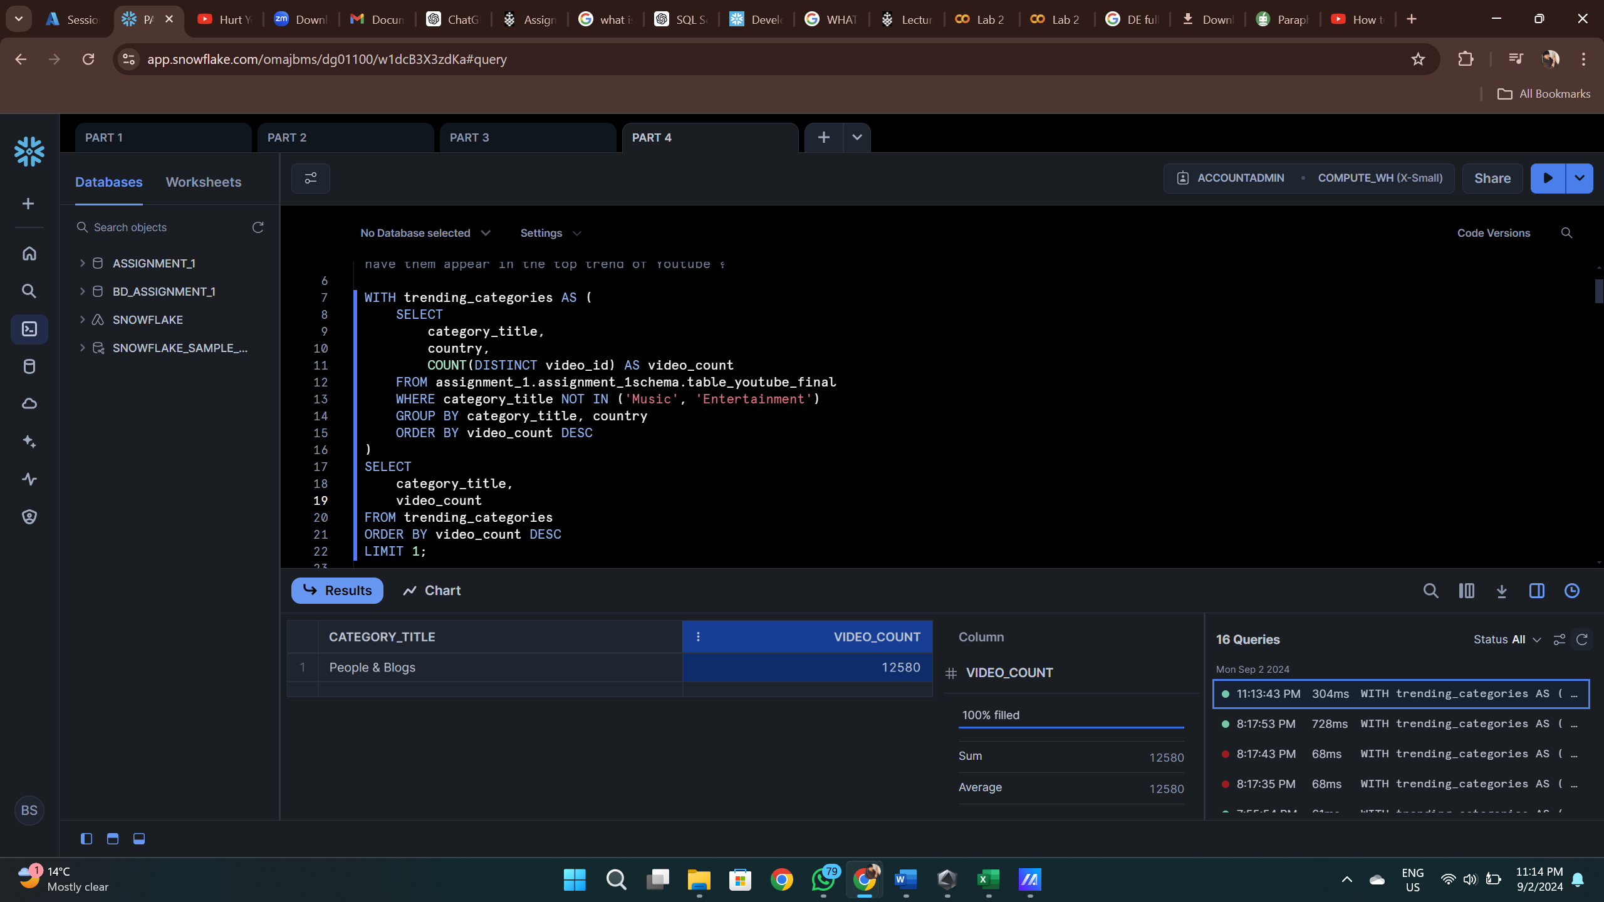

In this above query we can clearly see that the people & blog has the highest video count.

Will this strategy work in every country?

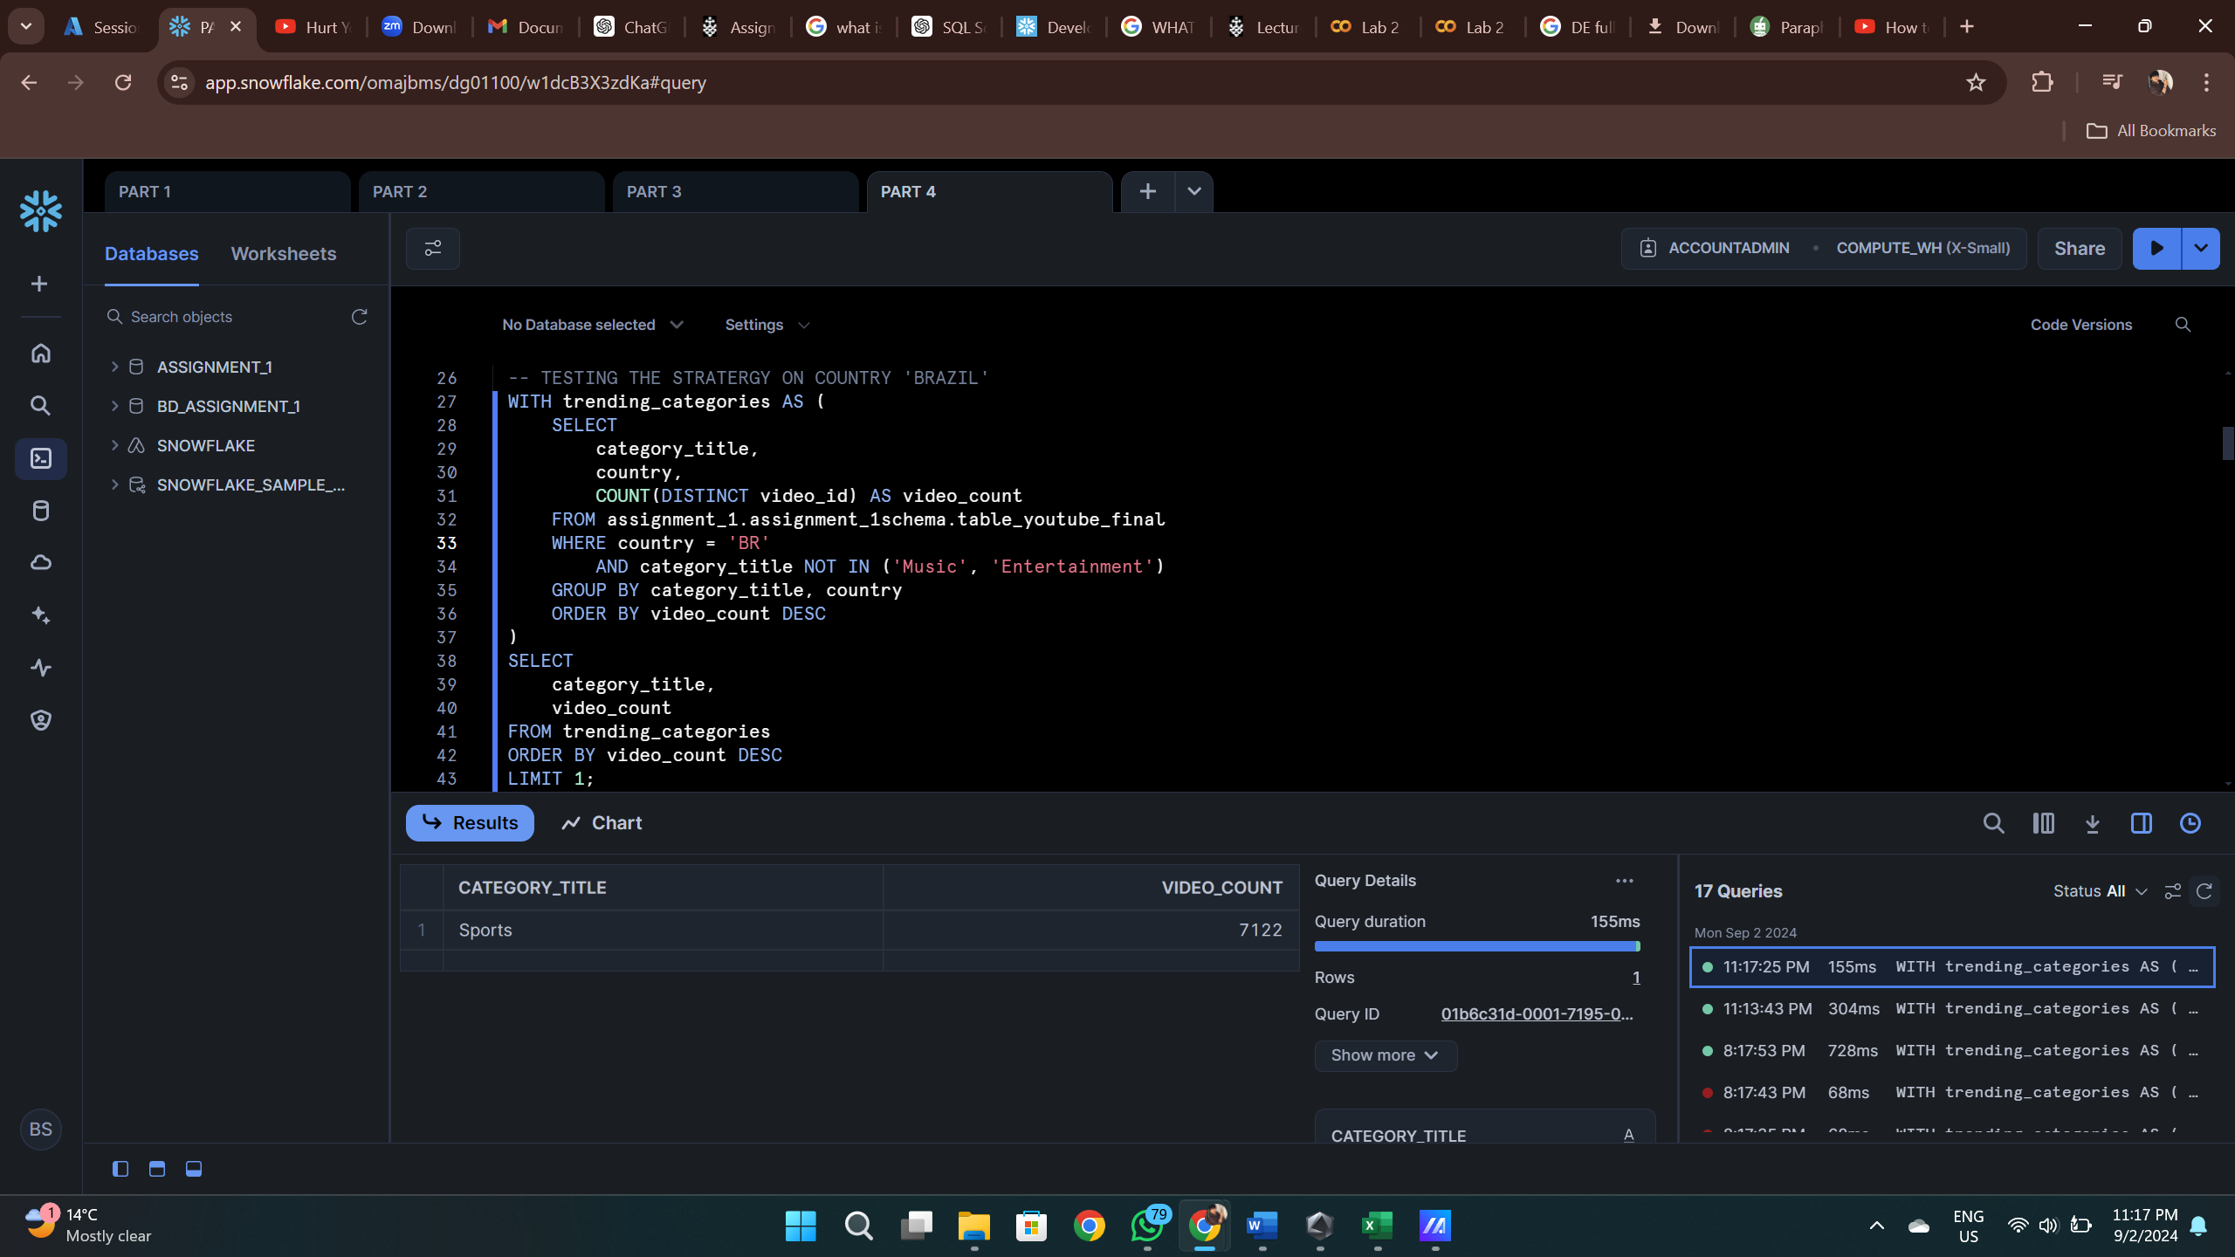

By adding a WHERE statement in the query to differentiate by different country, and for this assessment we have like 10 different countries and I did the same query for 10 different countries by changing the WHERE statement and based on the analysis, if I were to launch a new channel tomorrow, excluding Music and Entertainment categories, I would focus on “Gaming” content. This category consistently performed well across most countries.

# Challenges and Solutions:

Throughout the project, I faced several challenges:

1. Row Count Discrepancy: During data cleaning, the row count dropped unexpectedly after handling duplicates. This was resolved by revisiting the logic to ensure that only the correct rows were retained.
2. Data Consistency: Some country and category data mismatches were identified during merging. These were handled by carefully reviewing the join logic and ensuring no records were lost during the merge.

# Conclusion:

This assignment demonstrated the full data engineering pipeline from ingestion to analysis using Snowflake and Azure. The final dataset was cleaned, transformed, and analysed successfully. Key insights were derived about the top-performing video categories and channels. This project highlights the importance of efficient data handling, cleaning, and transformation techniques in a big data context.